UWM 2013-14 Transportation and Parking Study

|  |
| --- |
| Introduction |

UWM is committed to working constructively with its neighbors and regional partners to foster a more sustainable region as stated in the 2010 Master Plan and ongoing Strategic Plan. Part of looking outward has revealed the interdependency that our traveling population has with our partners, motivating the 2013-14 Transportation and Parking Study. This effort’s goals include:

“We value physical and virtual connectivity within and across campus locations, and with our local, regional and global partners.”  *Master Plan Report, 2010*

* Creating a **campuswide strategic and cost-effective approach** to sustainable transportation
* **Reducing impacts** of commuter trips
* Developing **local and regional partnerships** to improve mobility
* Accommodating 21st-Century travel habits

Our work has revealed many valuable findings worthy of a broader community dialogue, as summarized below.

|  |
| --- |
| Parking |

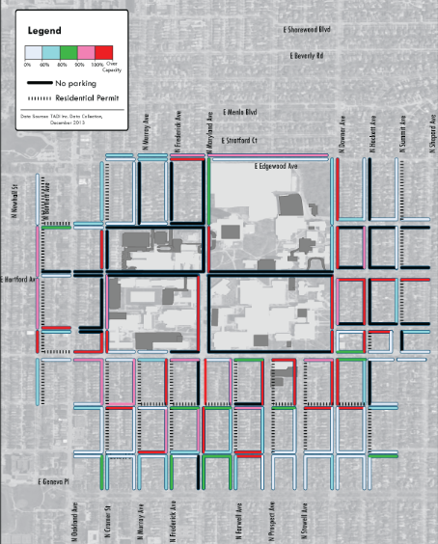In a recent survey, **42% of UWM students and 71% of UWM employees stated they drive to campus**. This means that as many as 5,400 cars may come to the Kenwood campus area.

ON-STREET Parking Utilization on a Typical Weekday, Midday

In the typical school day, from 8 a.m. to 6 p.m. over 50% of UWM parking (including the lot at Capitol-Humboldt) will be occupied**. By 1 p.m., approximately 90% of on-campus parking facilities will be occupied**, so over 1,000 commuters have to wait for turnover or park on surrounding streets.

Among other findings:

* Free parking areas fill up first and early on campus
* The remote parking distance is less of an obstacle than the price
* 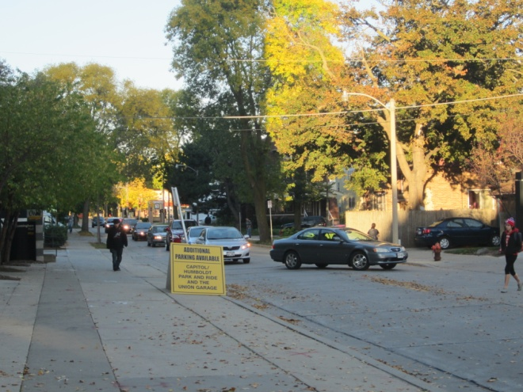Regulations, signage, and the permit/pricing structure are complicated

|  |
| --- |
| Transit |

There are a variety of mass transportation services at UWM:

* Public bus (MCTS)
* Intercity buses (Wisconsin Coach)
* Remote parking shuttles (UWM Parking & Trans.)
* Intra-campus dorm shuttles (UWM Housing)
* Late-night vans run by UWM students (BOSS)

These services have varying degrees of popularity. For example, about **4,440 riders leave the Kenwood campus every day on a MCTS bus.** However, the services have different financial sources and restrictions on who can ride them (and how much they pay). This complicated structure of transit may discourage potential riders.

Among other findings:

* Strong demand for late-night service, regardless of carrier
* Service is good, but service quality (branding, vehicles, stops) could be improved
* Overlaps between UWM and MCTS service are inefficient

|  |
| --- |
| Bicycles and Pedestrians |

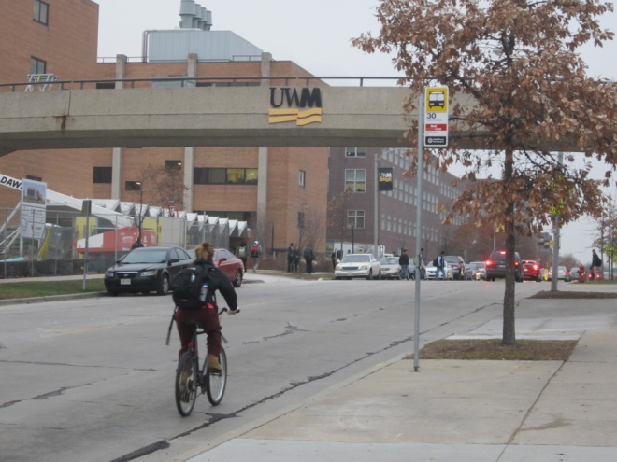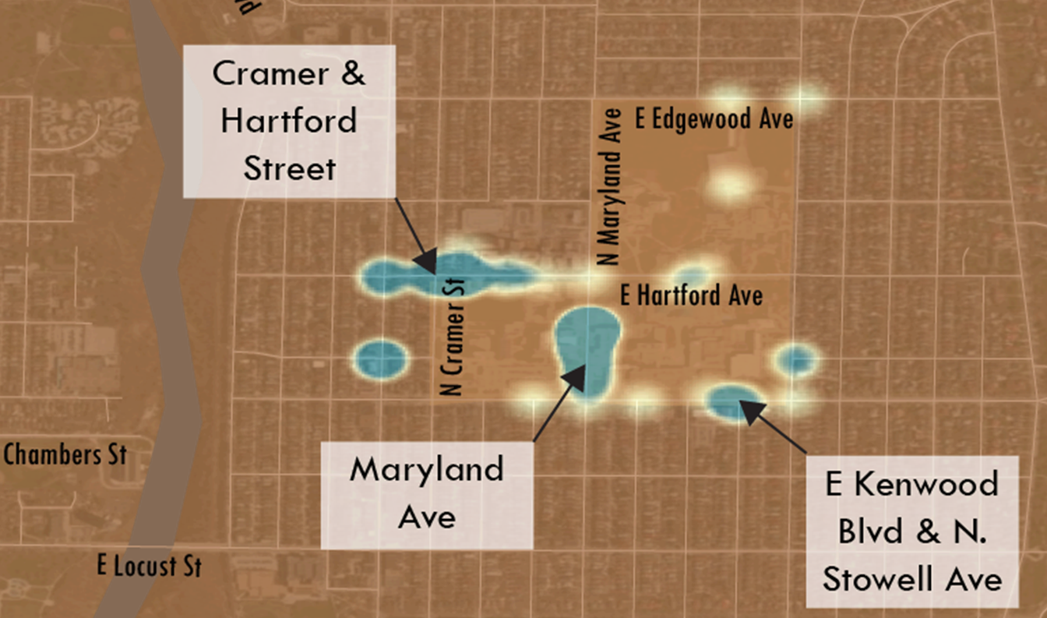UWM takes pride in being a multimodal campus. Many initiatives to get people to bike and walk to campus—as opposed to drive— are currently underway. While the on-campus bicycle network is generally robust, the experience of biking off campus is perceived as unsafe for casual riders. There is **capacity for over 1,200 bicycles to park**, but people still illegally lock their bikes to railings. The neighborhoods surrounding UWM are safe and dense, but **multiple** **intersections were cited as dangerous for pedestrians to cross.**

Problem Intersections Surrounding Campus

Among other findings:

* Kenwood Boulevard is perceived as a barrier limiting the desire to walk/bike to and from campus
* In the heart of campus, Maryland Avenue is a source of constant vehicle/pedestrian conflicts
* Local connections to the Oak Leaf Trail are poor
* Connections to off-campus facilities (such as the Zilber School of Public Health) are needed