PRESS RELEASE
August 1, 2014

Please post on your Calendar of Events and include in your announcements of happenings around town.

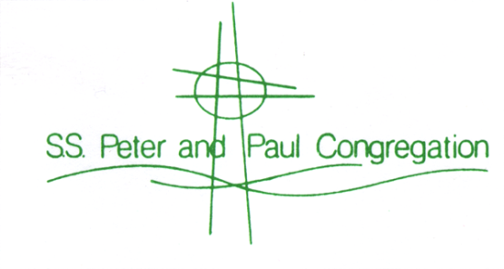
“The Heart of Christ in the Heart of the East Side”

Paul Cebar and Tomorrow Sound Headline
Saints Peter & Paul Block Party
September 13, 2014.

This neighborhood festival is a hidden gem on Milwaukee’s East Side. It’s close enough to home to call your own, and it’s free and open to the public. Held the Second Saturday in September, this festival is just the ticket to end a busy summer. Located in the 2400 block of N. Murray Avenue, the activities begin at 2pm with children’s games and Murray’s Marketplace. Mad RED Kat, a youth band, hits the stage from 2pm - 3pm, and rock band Hail to the Zoo plays from 3:30pm – 6:30pm while you enjoy some of the last festival food of the season.

In conjunction with our celebration of 125 years as a parish, we have an All Alumni Reunion for SS. Peter and Paul Grade School and Catholic East Elementary at the Block Party this year. Everyone is welcome to reminisce about the good ‘ol days, with 5pm Mass and 6:30pm recognition in the music tent.

Gee Funny Farm will stroll the grounds from 3pm – 4:30pm, with several animals you can touch, even hug. Don’t let your kids miss the animals, live and up-close. Face painting and crafts are also available from 2pm - 7pm in the Family Fun area.

Stay for Paul Cebar and Tomorrow Sound from 7:30pm - 11:00pm. Take advantage of this opportunity to see Paul Cebar in a casual atmosphere with no cover charge. Burgers, our famous festival Brats, and homemade Desserts await you. Wine, Lakefront Brewery beer and Colectivo Coffee are available all day.

One lucky raffle winner will receive $1,000 cash, and First Prize is an iPad®. Other raffles include cash prizes and gift baskets. And our ever-popular HUGE Silent Auction returns from 2pm – 9pm, with Dining, Sports, Entertainment, Collectibles and MORE – it is one of the best you will find! Don't miss all of the fun, music, food and drink. An amount equal to 10% of raffle proceeds will be donated to St. Ben's Community Meal.

For a complete schedule of events, visit http://www.ssppmilw.org/blockparty or email us at SSPPBlockParty@yahoo.com.

S.S. Peter and Paul Congregation, 2491 N. Murray Avenue, Milwaukee, WI 53211
414/962-2443, http://www.ssppmilw.org/blockparty
"the Heart of Christ in the Heart of the East Side"

